2022 Playoff Pick’Em   
Wildcard Round

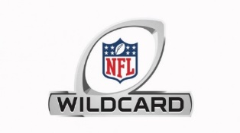  
Saturday, January 15 Time (ET) (5) Las Vegas – 10 points at (4) Cincinnati – 2 points 4:35

(6) New England – 8 points at (3) Buffalo – 3 points 8:15

Sunday, January 16 Time (ET) (7) Philadelphia – 6 points at (2) Tampa Bay – 4 points 1:05

(6) San Francisco – 10 points at (3) Dallas – 2 points 4:40

(7) Pittsburgh – 8 points at (2) Kansas City – 3 points 8:15

Monday, January 17 Time (ET)

(5) Arizona – 6 points at (4) Los Angeles – 4 points 8:15

**Tiebreaker:** Total points scored in Sunday Night Football Game ___________

Name _________________________ Total Correct _________